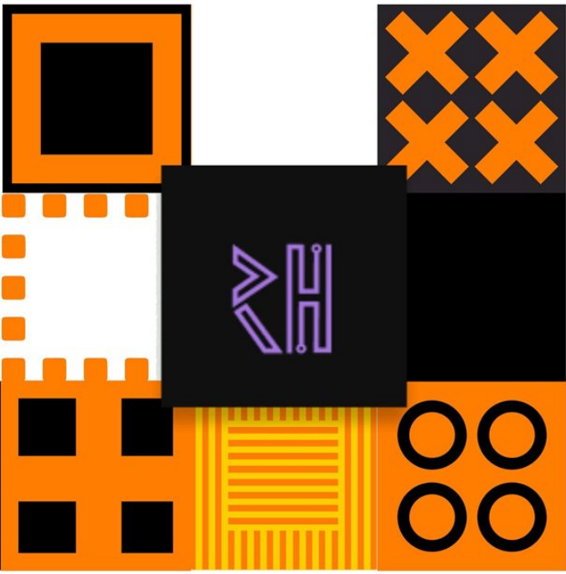

REVA HACK</> 2020

Elevator Pitch

**Team Un-Grads**

Shashank K S.

Siddesh B R.

Shaik Sahil Ahmed

Shashidhar Reddy

**Swastha App Face Mask Detector**

**November 04, 2020**

# **Overview**

The corona virus **COVID-19** pandemic is causing a global health crisis so the effective protection methods is wearing a face mask in public areas according to the **World Health Organization** (WHO). Reports indicate that wearing face masks while at work clearly reduces the risk of transmission. An efficient and economic approach of using AI to create a safe environment in a manufacturing setup. A hybrid model using deep and classical machine learning for face mask detection will be presented. A **face mask detection** dataset consists of with_mask and without_mask images , we are going to use Open CV to do real-time face detection from a live stream via our webcam. We will use the dataset to build a Swastha App face mask detector with computer vision using **Python**, **Open CV**, and **Tensor Flow and** **Keras.**

# 

# **Goals**

* Our goal is to identify whether the person on image/video stream is wearing a face mask or not with the help of computer vision and Machine learning.
* Following the outbreak of covid-19, everyone is aware of taking precautionary and protection measures about covid-19, so the identification of face masks would play a huge role in preventing corona virus.

# **Working Methodology**

We have divided two Phases in Swastha App (Face Mask Detector):

Phase 1: Train the Face Mask Detector –-we load the face mask data set having images of with mask and without mask collected from google and other sources and Train the face mask classifier with keras / Tenser Flow. Later Serialize face mask classifier to disk.

Phase 2: Apply Face Mask Detector – Load face mask classifier from disk and detect faces in image / video stream. Extract each face ROI and apply face mask classifier to each face ROI to determine **mask** or **no mask** . results are shown using web Camera whether a person is wearing a face mask or not with percentage Accuracy.

# 

# **Specifications**

* **Tech Stack / Frame works :** Python , Machine Leaning , AI and Computer Vision ,

Open CV , Tensor Flow and Keras , MobileNetV2 , Web Camera.

* **Programing Language :** Python